Digital Logic Design Laboratory

Lab 2

MSI Combinational Logic

Full name: Đỗ Minh Duy

Student number: ITITSB22029

Class: DLD Lab

Date: 5/4/2024

# I. Objectives

In this laboratory, students will study:

- Understand the operation of combinational logic circuit.

- The operation of some combinational ICs such as: full adder, parity generator checker, comparator.

# II. Procedure

1. Design the circuit that can detect BCD number:

The circuit that detects BCD number includes 4 inputs (A, B, C, D) and 1 output Y. The output Y is HIGH when the BCD numbers in the inputs.

- Build the truth table and the expression

A B C D Y

0 0 0 0 1

0 0 0 1 1

0 0 1 0 1

0 0 1 1 1

0 1 0 0 1

0 1 0 1 1

0 1 1 0 1

0 1 1 1 1

1 0 0 0 1

1 0 0 1 1

1 0 1 0 0

1 0 1 1 0

1 1 0 0 0

1 1 0 1 0

1 1 1 0 0

1 1 1 1 0

Implement the circuit via simulation software and paste the result in here



Y =





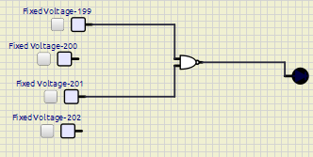

The inputs A, B, C, D wire up to switches and concurrently connect to BCD to 7 segment (in SimulIDE named as 7 Seg BCD shown as below)

Figure 1. BCD 7-Seg

Implement the circuit via simulation software and paste the result in here

Make comment on the results

If A is on 🡪 8

If B is on 🡪 4

If C is on 🡪 2

If D is on 🡪 1

If A is on 🡪 8

If C and D is on 🡪 3

If B and C and D is on 🡪 7

If B and D 🡪 5

If A and D is on 🡪 9

2. Design the Comparator from logic gates and IC

a. Build a one-bit comparator from logic gates

Construct one-bit comparator (2 inputs, 3 outputs) which are shown in the truth table below:

|  |  |  |  |  |
| --- | --- | --- | --- | --- |
| Input | | Output | | |
| A | B | A = B | A < B | A > B |
| 0 | 0 | 1 | 0 | 0 |
| 0 | 1 | 0 | 1 | 0 |
| 1 | 0 | 0 | 0 | 1 |
| 1 | 1 | 1 | 0 | 0 |

Write down the expressions for 3 outputs:

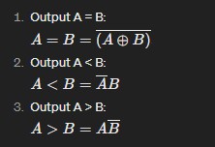

Implement the circuit via simulation software and paste the result in here

Make comment on the results

b. Build a 4-BIT comparator - IC 74HC85

The 4-Bit comparator IC 74HC85 is shown as below

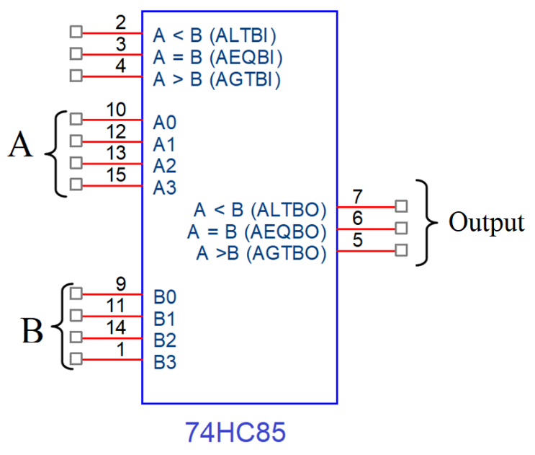

Figure 2. 4bit Comparators - IC 74HC85

- A and B are connected to data switches and Outputs are connect to LEDs

- Fill in the truth table of IC 74HC85.

|  |  |  |  |  |  |  |  |  |  |
| --- | --- | --- | --- | --- | --- | --- | --- | --- | --- |
| Comparing Input | | | | Cascading Input | | | Output | | |
| A3,B3 | A2,B2 | A1,B1 | A0,B0 | A > B | A<B | A=B | A>B | A<B | A=B |
| A3>B3 | X | X | X | X | X | X | 1 | 0 | 0 |
| A3<B3 | X | X | X | X | X | X | 0 | 1 | 1 |
| A3 =B3 | A2>B2 | X | X | X | X | X | 1 | 0 | 0 |
| A3 =B3 | A2<B2 | X | X | X | X | X | 0 | 1 | 0 |
| A3 =B3 | A2=B2 | A1>B1 | X | X | X | X | 1 | 0 | 0 |
| A3 =B3 | A2=B2 | A1<B1 | X | X | X | X | 0 | 1 | 0 |
| A3 =B3 | A2=B2 | A1=B1 | A0>B0 | X | X | X | 0 | 0 | 1 |
| A3 =B3 | A2=B2 | A1=B1 | A0<B0 | X | X | X | 0 | 1 | 0 |
| A3 =B3 | A2=B2 | A1=B1 | A0=B0 | 1 | 0 | 0 | 1 | 0 | 0 |
| A3 =B3 | A2=B2 | A1=B1 | A0=B0 | 0 | 1 | 0 | 1 | 1 | 0 |
| A3 =B3 | A2=B2 | A1=B1 | A0=B0 | X | X | 1 | 0 | 0 | 1 |
| A3 =B3 | A2=B2 | A1=B1 | A0=B0 | 0 | 0 | 0 | 1 | 1 | 0 |
| A3 =B3 | A2=B2 | A1=B1 | A0=B0 | 1 | 1 | 0 | 1 | 0 | 0 |

Implement the circuit via simulation software and paste the result in here

Make comment on results:

The board's output and the circuit's performance on Simulink IDE are in agreement

c. Design eight-bit comparator using IC 74HC85

Data of X and Y are driven using switches.

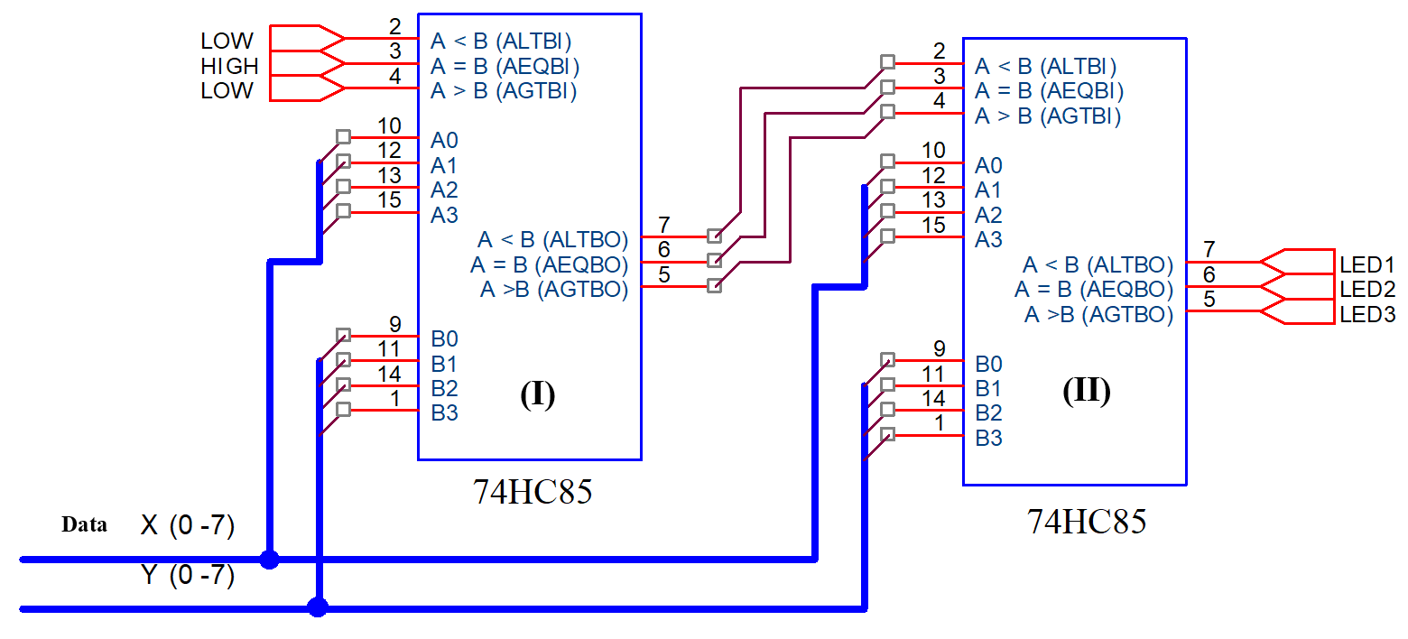

Implement the circuit via simulation software and paste the result in here

Based on your circuit, fulfill the following table:

|  |  |  |  |  |
| --- | --- | --- | --- | --- |
| X | Y | Result | | |
| LED1 | LED2 | LED3 |
| 0101 0101 | 0101 0111 | 1 | 0 | 1 |
| 1111 0101 | 0101 0111 | 0 | 0 | 1 |
| 1111 0101 | 1111 0100 | 0 | 0 | 1 |
| 1001 0110 | 0101 1000 | 0 | 0 | 1 |
| 1111 0100 | 1101 1101 | 0 | 0 | 1 |
| 0110 1100 | 0110 1100 | 0 | 1 | 0 |

Make comment on results and give a brief explanation of the cascading connection

Cascading is the use of a circuit breaker's current-limiting capacity at one point to allow the installation of lower-rated and hence less expensive circuit breakers downstream. The output of the circuit on the board agrees with the outcome of the circuit on simulIDE.

3. Design the Parity Generator and Parity Checker

a. Build a 3-bit parity generator and parity checker only using XOR gate

Fulfill the truth table

|  |  |  |  |  |
| --- | --- | --- | --- | --- |
| A | B | C | Even Output | Odd Output |
|  |  |  |  |  |
|  |  |  |  |  |
|  |  |  |  |  |
|  |  |  |  |  |
|  |  |  |  |  |
|  |  |  |  |  |
|  |  |  |  |  |
|  |  |  |  |  |
|  |  |  |  |  |

Write the expressions

Using K-map to simplify the expressions

Implement the circuit via simulation software and paste the result in here

Implement the circuit using IC 74HC86 (quad 2-input XOR gate) via simulation software and paste the result in here

Make comment on results

b. Build a 4-bit parity generator and parity checker only using XOR gate

Fulfill the truth table

|  |  |  |  |  |  |
| --- | --- | --- | --- | --- | --- |
| A | B | C | D | Even Output | Odd Output |
|  |  |  |  |  |  |
|  |  |  |  |  |  |
|  |  |  |  |  |  |
|  |  |  |  |  |  |
|  |  |  |  |  |  |
|  |  |  |  |  |  |
|  |  |  |  |  |  |
|  |  |  |  |  |  |
|  |  |  |  |  |  |
|  |  |  |  |  |  |
|  |  |  |  |  |  |
|  |  |  |  |  |  |
|  |  |  |  |  |  |
|  |  |  |  |  |  |
|  |  |  |  |  |  |
|  |  |  |  |  |  |

Write the expressions

Using K-map to simplify the expressions

Implement the circuit via simulation software and paste the result in here

Implement the circuit using IC 74HC86 (quad 2-input XOR gate) via simulation software and paste the result in here

Make comment on results